Westlaw Law Review Series

Cite Checking

- Finding Sources on Westlaw
  - Access the Westlaw Directory
  - Using the SEARCH feature, type the name of a database in the template
  - Example: The ABA Journal E-Report

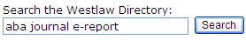

  - You will see the list of databases, including The ABA Journal E-Report

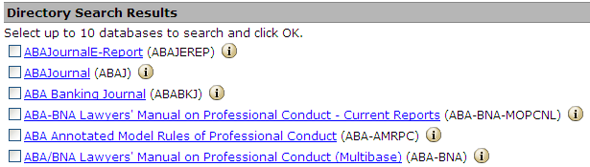

- Using Scope
This is the Scope icon:

Scope will let the researcher know the coverage of a database on Westlaw and whether or not we have the information they are trying to cite check. Scope will give the beginning coverage and whether or not the database is still current.

This is a critical task when you are cite checking to first learn whether or not we have the information that you are looking for.

- Title/Author Search
Using the Fields feature in Terms & Connectors you can run the following searches to retrieve a document to verify:
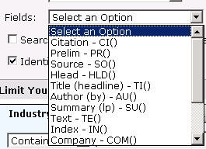

A Title search will look for key words in the title of an article (required in Bluebook or ALWD citation format) Select TI from the field pull down:



This will find any article with the word LAWYER in the title

An Author search will look for articles written by a particular author, but since an author may write regularly, you might also consider adding a date from the citation to restrict your search further



  - Author Search: AU(rodent) & DA(after 2002)



  - This will find everything written by The Rodent after 2002. (44 docs)

- LOCATE
Locate is a tool that you can use to find a particular quote or specific part of the document by using one key word from the article/quote that you need to verify.

Enter an additional term/phrase: “summer associate” and click LOCATE

This will lower our list from over 40 to 4 results, well within the ability to scan the results to find our document to verify.

- PinPoint Citations/Star Pages

PinPoint Citations, jump you directly to the part of the case you need: 162 N.E. 103

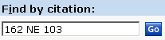

Star Paging is Westlaw’s breakdown of pages for a various reporter

Single Star=State Reporter, Double Star=National Reporter

When you click print, you can print specific star pages or range of star pages for your cite checking assignment.

- PDF Printing
Exclusively on Westlaw, you can retrieve the reporter version of the case and print to an attached printer to attach to your cite checking assignment.


- Index to Legal Periodicals/Current Index to Legal Periodicals/Legal Resource Index*

From your law review tab find these databases.

All of these databases will be helpful in locating book/periodical resources that may not be available on Westlaw, but may be available in your library or via interlibrary loan. The listings will give you ISBN/ISSN numbers, publication dates, and other possible helpful information.

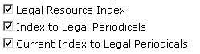

* Note: you will need to verify whether or not your school has access to ILP, LRI, or CILP, these are not available on all accounts.

